Contents

Introduction 1

Prerequisites 1

Create a VM from VM Depot Image 1

Select Image 1

Create VM 3

Contribute to VM Depot 4

Create an Account 5

Capture an Image 5

Get Image URL 5

Make Image Public 6

Publish Image 7

# Introduction

This guide gives and overview of VM Depot, how to use it and how to contribute.

VM Depot is a community-driven catalog of preconfigured operating systems, applications, and development stacks that can easily be deployed on Windows Azure.

## Prerequisites

Azure CLI installed, Azure account created.

# Create a VM from VM Depot Image

## Select Image

Navigate your browser to http://vmdepot.msopentech.com/List/Index. You will see a filterable list of virtual images. For example, if you are interested in scientific python development, you could search for iPython:

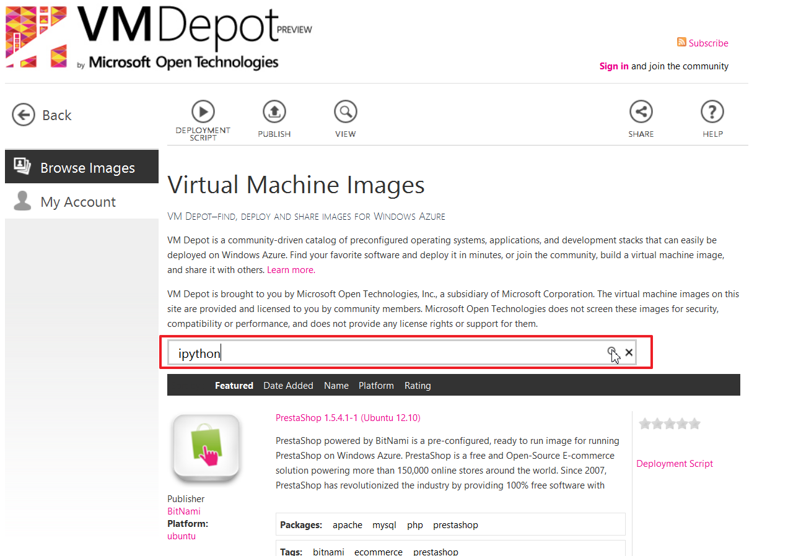

You should see a result called “Azure Data Science Core” that includes scientific python packages. On the right, you will find a link labelled “Deployment Script”. Click on it:

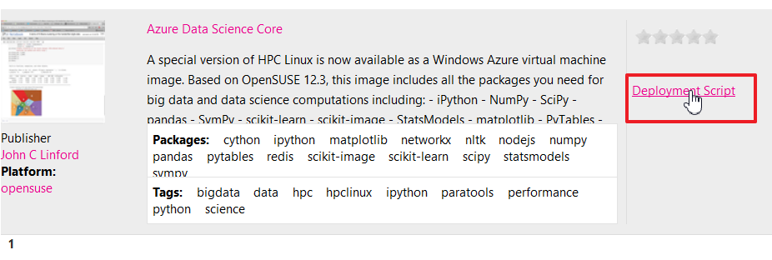

You might need to accept the “Terms of Use” that open up at the top of the page. Click on “I Agree”:

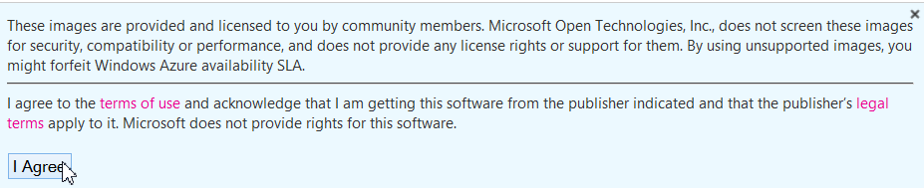

Select the region you want to deploy the image to from the dropdown:

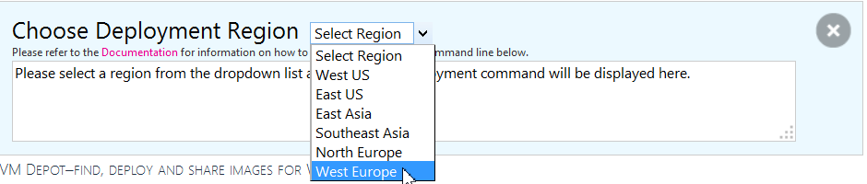

After selecting the region, you fill find the deployment script that you should copy and paste:

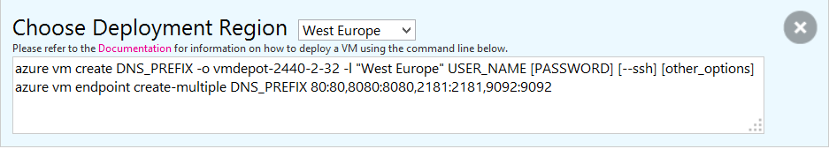

Note that this script still contains placeholders. In this example, the deployment script is:

azure vm create DNS_PREFIX -o vmdepot-2440-2-32 -l "West Europe" USER_NAME [PASSWORD] [--ssh] [other_options]

azure vm endpoint create-multiple DNS_PREFIX 80:80,8080:8080,2181:2181,9092:9092

The first line creates the virtual machine. The second one defines endpoints so you can access services from the outside.

Replace DNS_PREFIX with the domain name you want (DNS_PREFIX.cloudapp.net”), USER_NAME with the intended user name. If you do not specify a password, you will be prompted for it. Use the --ssh flag to allow for SSH access.

## Create VM

After you have edited the information, open up a shell/command prompt and execute the first command. This will create the virtual machine:

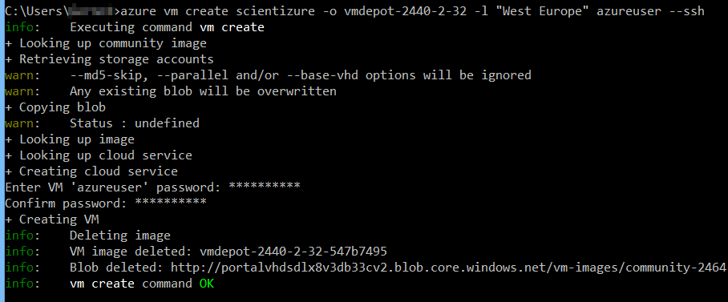

After the VM is created, you should execute the second script to create the necessary endpoints. Remember to replace the DNS_PREFIX with the one you used during VM creation. The operation will take a couple of moments:

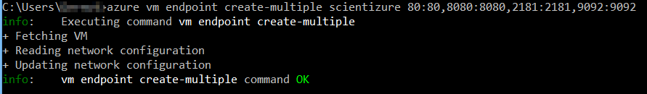

Note that the provisioning process can take some time. You can always check the status of your VM with the command:

azure vm list

You will have to wait until the VM is in “ReadyRole” to use it:

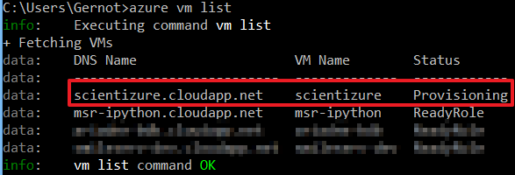

# Contribute to VM Depot

If you have images that you want to share with the community, you can do so by publishing it to VM depot.

## Create an Account

In order to contribute, you have to create an account first. On the VM Depot site, click on “Sign in” on the top right:



You should use the same account you use for your Azure subscription:

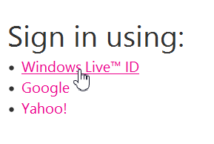

On the next page, fill out the required information.

## Capture an Image

Capturing an image is covered in a different hands-on.

## Get Image URL

In order to publish an image to VM Depot, you need the public URL of the image. In the command line, use the following command:

azure vm image show <image-name>

This will output (amongst other information) the URL of the image:

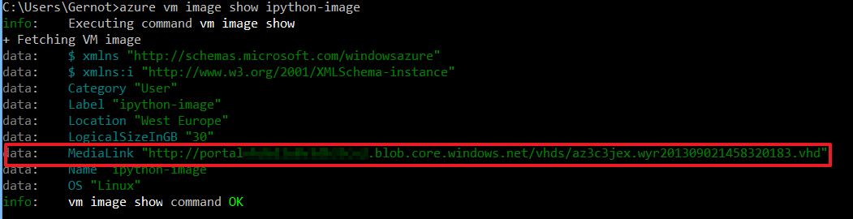

## Make Image Public

The image must be publically accessible in order to be published on VM depot. An easy way to do this is to log onto the Azure portal and select the appropriate storage account and the “Containers” tab:

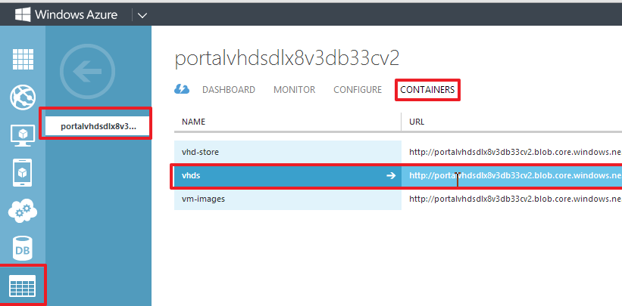

Next, select the appropriate container (for *.blob.core.windows.net/**vhds/**\* this would beselect “vhds” for example) and in the bottom, select “Edit”:

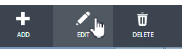

In the “Container Metadata” window, set access to “Public Blob”:

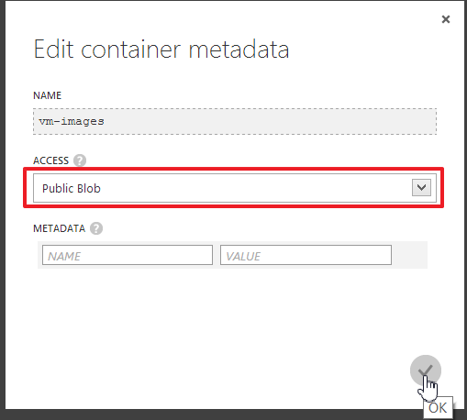

## Publish Image

On the VM Depot site, select “Publish”:

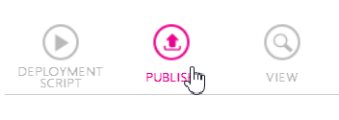

You have to fill out some information about the image, including:

* The image name
* The image URL
* The distribution used
* Any endpoints you want add (optional)

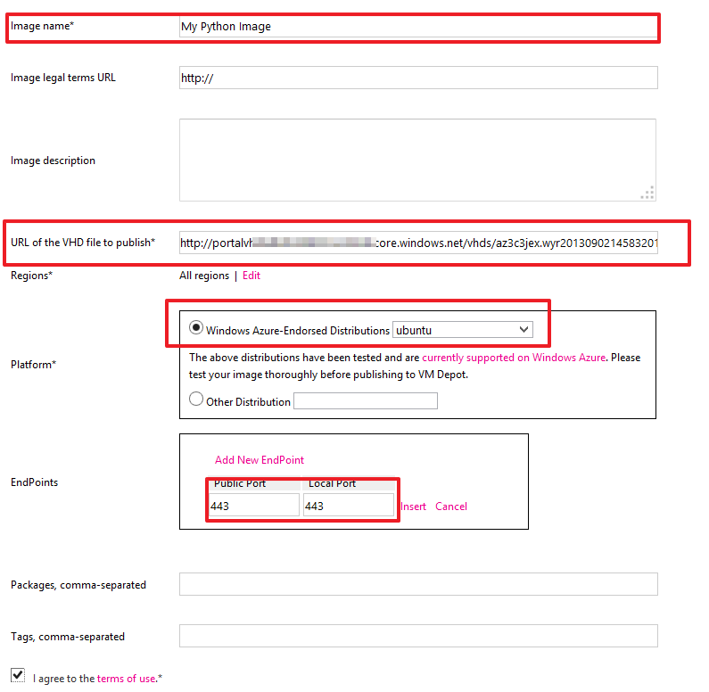

After filling out all the information, click on “Publish”. This will start the publishing process that copies the image to the selected regions:

